

Financial Report for the

Board of Directors

Report for February 2023

Prepared by Gwen Hertz, Treasurer

March 5, 2023

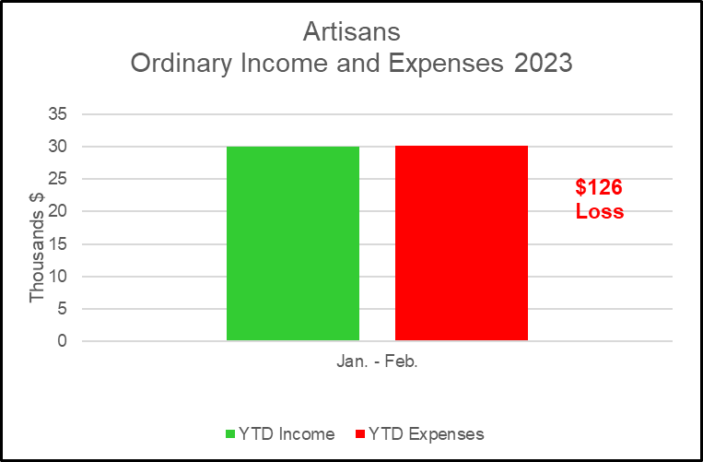

**Bank Balance end of Month = $62,854.37**



###### Total Amount of Discounts Given that Were Paid for by Artisans

* This does not include Artist Discounts.

|  |  |
| --- | --- |
| Month | Total Amount of Discounts Given $* |
| Jan. | 152 |
| Feb. | 615 |
| Mar. |  |
| Apr |  |
| May |  |
| June |  |
| July |  |
| Aug. |  |
| Sept. |  |
| Oct. |  |
| Nov. |  |
| Dec. |  |
| TOTAL | 767 |





