

Financial Report for the

Board of Directors

Report for June 2023

Prepared by Gwen Hertz, Treasurer

July 2, 2023

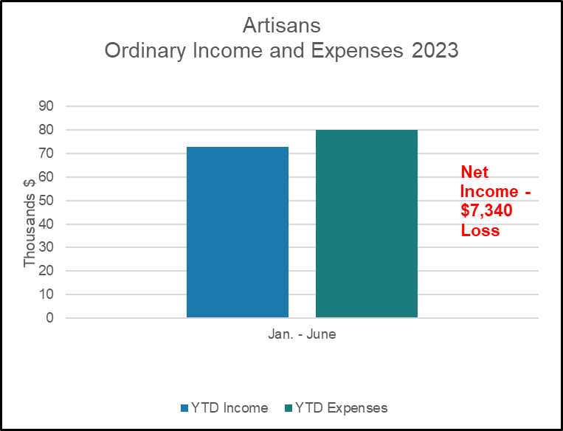



**Bank Balance end of Month = $51,096.52**













###### Total Amount of Discounts Given that Were Paid for by Artisans

* This does not include Artist Discounts.

|  |  |
| --- | --- |
| Month | Total Amount of Discounts Given $* |
| Jan. | 152 |
| Feb. | 615 |
| Mar. | 137 |
| Apr | 47 |
| May | 209 |
| June | 37 |
| July |  |
| Aug. |  |
| Sept. |  |
| Oct. |  |
| Nov. |  |
| Dec. |  |
| TOTAL | 1,197 |

 







