

Financial Report for the

Board of Directors

Report for January 2023

Prepared by Gwen Hertz, Treasurer

February 12, 2023

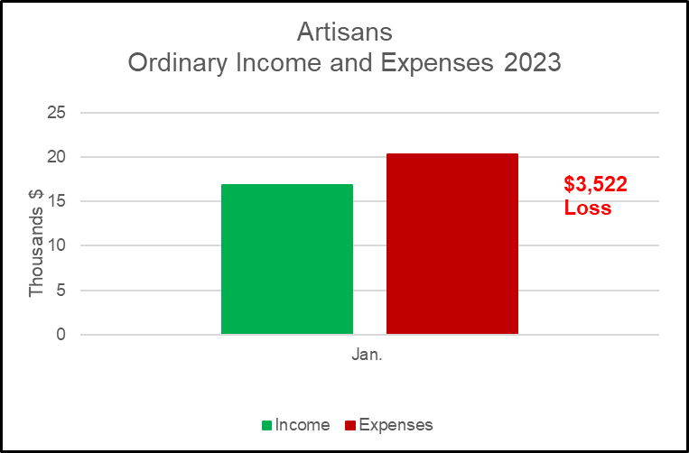

**Bank Balance end of Month = $58,517**







###### Consignor Sales

|  |  |  |  |  |
| --- | --- | --- | --- | --- |
| **Month** | **No. Items Sold** | **$ Total Sales\*\*** | **$ to Consignor\*** | **$ to Artisans\*\*\*** |
| Jan. | 53 | 1,193 | 656 | 536 |
| Feb. |  |  |  |  |
| Mar. |  |  |  |  |
| Apr. |  |  |  |  |
| May |  |  |  |  |
| June |  |  |  |  |
| July |  |  |  |  |
| Aug. |  |  |  |  |
| Sept. |  |  |  |  |
| Oct. |  |  |  |  |
| Nov. |  |  |  |  |
| Dec. |  |  |  |  |

* Actual pay to Consignor – 55% in Jan. Feb. paid at 50%. ** Without discounts paid by Artisans. ***Sales – Discount – Paid to Artist = $ to Artisans

###### Total Amount of Discounts Given that Were Paid for by Artisans

* This does not include Artist Discounts.

|  |  |
| --- | --- |
| Month | Total Amount of Discounts Given $* |
| Jan. | 152 |
| Feb. |  |
| Mar. |  |
| Apr |  |
| May |  |
| June |  |
| July |  |
| Aug. |  |
| Sept. |  |
| Oct. |  |
| Nov. |  |
| Dec. |  |
| TOTAL |  |











